Burnhaven School
Learning, Teaching and Assessment Statement 22/23
LEARNING AND ENGAGEMENT | QUALITY OF TEACHING
What statements are you currently focusing on? | What statements are you currently focusing on?
- Learners are increasingly responsible for and actively involved in planning and leading learning. Their views are sought, valued and acted upon across the school and wider community  - Pupils understand the purpose of their learning – good use made of AIFL strategies such as LI/SC (including co-construction)  - Learners have an increasingly accurate understanding of their own and others’ learning and are encouraged to talk about strengths and identify next steps. | - Teachers provide effectively organised and well managed learning experiences, clearly identifying the purpose of the learning and what is to be assessed.  - Teachers ensure that their learners understand the purpose of their learning and are provided with ongoing opportunities to plan and lead.  - Use of skilled questioning and engagement to promote curiosity, independence and confidence and to enable higher-order thinking skills in all learners  - Teachers provide quality feedback that helps learners be clear about strengths and next steps in learning.
EFFECTIVE USE OF ASSESSMENT | PLANNING, TRACKING AND MONITORING
What statements are you currently focusing on? | What statements are you currently focusing on?
- Learning, teaching and assessment are planned in an integrated manner identifying what is to be learned and assessed at the planning stage.  - Outcomes from assessment are shared with learners to engage them in reflection and identification of strengths and areas for development.  - Moderation processes and approaches are applied to all aspects of learning, teaching and assessment to improve the validity and reliability of judgements of progress and attainment within and beyond the school. | - Robust approaches to tracking and monitoring provide teachers with regular up to date data on young people’s progress. Tracking and monitoring processes include analysis of data linked to any barriers to learning. This may include SIMD profiles or any identified additional support need. As a result, pupils’ needs are well identified across the school.  - Analysis of data leads to appropriate interventions to address gaps in attainment and achievement. Data is also used to evaluate the effectiveness of interventions designed to improve outcomes for all learners.
Themes arising from our areas of focus on which to concentrate this session:
- Involving pupils in understanding their learning and how they can improve. Supporting them to understand the purpose of their learning and what their strengths and areas for development are.
- Ensuring assessment for learning is ongoing in each classroom in age appropriate ways.
- Improving moderation to ensure judgements are robust

Vision Values and Aims
VALUES | How is your learning and teaching offer shaped by your values?
Respect | Relationships are at the forefront what we do at Burnhaven and this includes how we teach our children and support them to learning, giving them feedback based on how we know them. Relationships are also important to how we, as a team, improve our practices.
Honesty | Honest feedback is given regularly to pupils and, indeed staff, as part of our moderation model. See above – open and honest discussion with learners about progress and moderation of learning and teaching.
Trust | All stakeholders trust the data available and seek to adapt teaching and learning based on this. Our professional development and moderation model is based on trust in colleagues.
Kindness
Effort | As we value effort, there is an expectation that staff and pupils apply this to teaching and learning, challenging ourselves and each other to do better.
VISION | How is your vision underpinning your learning and teaching offer?
“A Haven where futures begin”
Our vision is to create a haven or safe place where children can grow as individuals and a place where children feel prepared for a future in the 21st Century.
For this reason, positive relationships exist between staff and learners. The school has an ethos of mutual respect exists which is conducive to learning and teaching. Learners have and understanding of their rights and respect the rights of others. Learners’ wellbeing is a priority across all classes, teachers know learners well and plan interventions to support social, emotional and academic learning. Learners are offered experiences which are innovative and creative. They promote engagement and curiosity. Teaching approaches to meet the needs of our learners and offer the opportunity to develop skills which they can use in their futures, whatever that brings.
AIMS | How are your aims being achieved/realised through your learning and teaching offer?
At Burnhaven we believe we are here to:
- Ensure that every member of our Burnhaven family is welcomed and heard – We are working to develop pupil voice in our lessons.
- Provide quality learning experiences which foster curiosity for life-long learning. – We seek innovative approaches to teaching and learning. We aim to use questioning which challenges thinking.
- Encourage children to step out of their comfort zones and build their resilience. – We try to engage children in their learning and challenge them to set their own next steps.
- Offer a nurturing environment where children are encouraged to work together and support each other, recognising and celebrating each other’s unique qualities. – We are working to ensure learners understand their strengths and areas for development.

4 Capacities
How are the 4 capacities being developed through your learning, teaching and assessment?
Successful Learners | Confident Individuals
Teaching and learning opportunities at Burnhaven are innovative and creative, encouraging enthusiasm and motivation. Burnhaven learners value effort and aim high.  With the development of pupil voice, children will be able to make even more reasoned evaluations of their next steps. | Our approaches to teaching and learning allow children to assess risk themselves and make informed choices. They are aware of their own needs and the needs of others.  With the development of pupil voice in learning activities children will be able to express where they are with their learning and where they need to improve.
Responsible Citizens | Effective Contributors
Teaching and learning contexts help our children to understand the world around them and their place in it. They are developing informed opinions and are able to make decisions based on their values and beliefs.  Our children recognise the needs of others and how they can support each other. | Our approaches to teaching and learning encourage children to create and develop, to solve problems, take the initiative and lead learning. They show enterprising attitudes.  Development of their understanding of their strengths and areas for development will build their resilience.

Stakeholder Feedback
Our children say that they enjoy reading, adding, writing and practical experiments. They enjoy construction in the STEM classroom. Our children say they find reading and writing challenging and they find it difficult if they don’t know what to do and if they have to do lots of things in their head. They would like more challenge, more play, more creativity, more technology and some baking. They would like their learning to be clearer during play. They would like to help improve our learning and teaching by challenging themselves more, by sharing their strategies and by using more technology.
What are you children currently saying about learning, teaching and assessment?
Our children have voice in the school and are engaged in their learning. We know them well and adapt for them. Differentiation and support is a strength.
What are you staff currently saying about learning, teaching and assessment?
We now need to work on purpose of learning, involving children in their own assessment and moderation of our judgements. We are on a journey towards ensuring our teaching, learning and assessment fully underpins our vision.
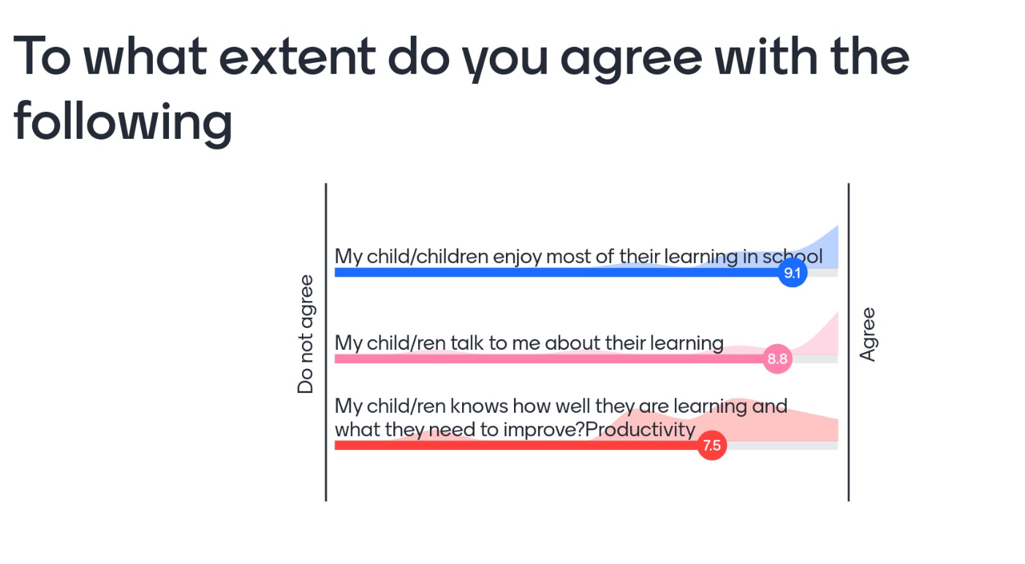
What are you parents currently saying about learning, teaching and assessment?

The menti check in didn’t capture all families as the devices didn’t always allow a second entry. This will have to be addressed for the future. However, this snap shot of half our families suggests that our children enjoy their learning but need support to know themselves how to improve.

