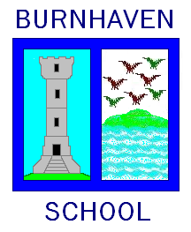

Standards & Quality Report
2022-2023
&
School Improvement Planning
2023 – 2024

School Forward

We are pleased to present both our Standards and Quality Report for Session 2021-22 and our School Improvement plan for the current session 2022-23. This report forms part of our quality improvement framework and provides important information regarding our school’s progress to date and identifies our next steps in school improvement.

Self-Evaluation for Self-Improvement is at the heart of our practice in Burnhaven school. We continue to develop our practice and procedures to collect appropriate data and in make robust use of evidence as a basis for judgements regarding the impact of our work on our learners.

How are we doing? Overall, we believe we are providing good education for our learners with areas for improvement. We want to provide an excellent education and continuously seek improvements for our learners.

How do we know? Our attainment data, observations, focus groups and questionnaires give us clear evidence of how we are doing and what we need to do next.

What are we going to do now? Our evidence suggests that while our children are making progress, we have work to do around learning, teaching and assessment with a focus on tracking and moderation and creating assessment capable learners in the coming session.

Looking inwards We continue to evaluate our working practices to improve the experiences and outcomes for our children through regular tracking and discussion.

Looking outwards to find out more about what is working well for others locally and nationally we work alongside local schools and schools in other authorities to challenge ourselves and explore best practice. Practitioners engage with social media and online learning to explore new ideas and critically decide if this is relevant to our school

Looking forwards we strive to be a school which offers very good and excellent education.

At Burnhaven, we continue to be committed to working closely with our community and all other stakeholders that support the education we provide. Together we are working hard to ensure all our pupils get the best possible start in life and are enabled and encouraged to maximize their potential.

We realise that within education things never stand still or stay the same. We continue to strive to meet the changes and challenges. Through this document we hope that you will get a sense of our developments, successes and areas for further growth.

Anita Buchan
Head Teacher

The School and its context

Vision for the school
Here at Burnhaven School we are a family. As with our own families, we want our children to be empowered to be themselves and to grow into their full potential.
As such, Burnhaven School’s vision is to become a Haven which is a safe environment where children can thrive, encouraging each other to be the best they can be.
We strive to prepare our children for their futures by providing engaging teaching and learning experiences which develop skills for life.

Values that underpin our work
The following values are promoted at Burnhaven School:
Respect, Kindess, Effort, Honesty and Trust

What do we aim to achieve for our children/pupils?
- Ensure that every member of our Burnhaven family is welcomed and heard.
- Provide quality learning experiences which foster curiosity for life-long learning.
- Encourage children to step out of their comfort zones and build their resilience.
- Offer a nurturing environment where children are encouraged to work together and support each other, recognising and celebrating each other’s unique qualities.

Context
Burnhaven Primary School is situated in the north-east coastal town of Peterhead, approximately 30 miles from Aberdeen. It serves the catchment area of south-west area of the town and the surrounding rural area.

On leaving Burnhaven School, pupils transfer to Peterhead Academy, which has 11 associated feeder primary schools as part of the Peterhead Children’s Services Network (CSN). Within the Peterhead CSN, all services operate in an integrated framework in order to ensure that each child has the fullest opportunity to maximise his or her potential.

The school accommodation includes the main building and two temporary classrooms. The main building comprises two classrooms, one multi-purpose room, administration offices, the school hall and servery.

The current roll is 36 children. The pupils are organised into 2 classes. The school has 3.0 full time equivalent staff including the Head Teacher. The school is also supported by the local Peterhead Children’s Services Network and additional sporting opportunities are arranged by the Active Schools Coordinator. Teachers from the Peterhead Primary Schools Area Team provide additional support for learning 1 day per week.

Our teaching team is supported by 1 full time pupil support assistant a school administrator, a clerical assistant, a part-time janitor, and kitchen and cleaning staff.

The school has a very active and supportive Parent Council and encourages involvement of parents in the work of the school. Their interests extend well beyond the normal fund-raising and social activities. Several enthusiastic pupil groups are also in place including the Pupil Council, Eco Committee, Healthy living group and Rights Respecting Schools Group. Pupils in the senior classes are prefects, librarians and play leaders.

The school manages its budget in line with Aberdeenshire Council guidelines and priorities are identified in line with the School Improvement Plan.

Creating an ethos of achievement is central to what we do and we work hard to establish an environment in which all our pupils, staff and members of our community are able to fulfil their potential and expectations. We know our local community and families well and as such, the school aims to provide a nurturing environment that is reflective of pupils needs. Moreover, local connections with the world of work are being sourced and used as appropriate to develop skills for life and work.

Very few children at Burnhaven live in an area of deprivation. Analysis of SIMD data indicated that the majority of children are from decile 7 or above. Therefore, the school was allocated a small portion of the Pupil Equity Fund. These monies are used to target literacy and numeracy and wellbeing interventions.

This session we will continue to improve consistency of our teaching, learning and assessment practices in a supportive and collaborative way, increasing our use of technology across the curriculum and we willcontinue a focus on the health and wellbeing of our learners by further developing pupil voice and pupil involvement in their learning.

Please refer to Burnhaven School Prospectus for further information. This is available in school or at our website. www.burnhaven.aberdeenshire.sch.uk

Standards and Quality Report 22-23

Impact of our developments
In this section we will outline the Targets we set last session and identify the progress we have made during session 2022-2023.
Key priority 2022-2023 | Key actions undertaken | Impact (achieved throughout 2022-2023)
- To Improve quality and consistency of teaching and learning experiences across the school for improved attainment and improved engagement including exploring a variety of learning environments, increased play and embedding digital technology. | Actions  - Increase pupil voice in leading learning.  - Plan for effective use of the STEM classroom.  - Increase play-based pedagogy across the school and develop approaches to planning and recording the learning that takes place.  - Develop the use of outdoor spaces and embed outdoor learning into practice.  - Develop children’s understanding of outdoor spaces (Eco Schools groups)  - Increase children’s confidence when talking about their learning.  - Develop a skills framework to help children talk about their learning.  - Increase use of digital technologies across the curriculum.  - Engage with new Aberdeenshire Teaching and Learning Toolkit.  - Review the Burnhaven Lesson as a blueprint for Teaching, Learning and Assessment. Develop a consistent understanding of this.  - Develop Quality Assurance practises to ensure consistent quality.  - Develop consistent learning and teaching curriculum approaches and use of key resources.  Professional Learning  - Attend launch of Aberdeenshire materials for HT and PT.  - Inservice session with Mark Burns (all staff)  - Inservice session with Shirley Clarke (all Staff)  - Further reading and debate around assessment, moderation, tracking and analysis. (4th quadrant  Policy Development  - Develop Teaching and Learning statement for this session and review for next session.  - Review Teaching and Learning Blueprint in line with Aberdeenshire Toolkit | Relaunching community groups, senior leadership groups and pupil leadership questions in assembly has increased pupil voice at Burnhaven.  There are now regular opportunities for Play across the whole school which are both planned for and pupil led. Work has begun on how this can be evidenced and recorded.  Children have started to talk about their learning but this is not yet specific enough.  A skills framework, looking at cognitive skills and skills for life, learning and work has been investigated but still needs to be firmed up, launched and displayed for children to use when discussing their learning.  All teachers engaged with the Aberdeenshire Teaching and Learning tool kit as part of exploring our Burnhaven Lesson Blue Print. The overall expectations of a lesson have been shared and agreed. Now we need to look into each element and identify each element should look like. Self evaluation practices have been agreed and initiated to ensure consistency but more work is required to show improvement and to move towards peer evaluation and team evaluation.  All staff attended inservice sessions and have discussed and debated the ideas presented to include in our Burnhaven Lesson framework.  Regular reflection on each of the 4 quadrants has informed our self evaluation. Our Teaching and Learning Statement recognises what we do well in including pupil voice and in providing pupil choice. However, we recognise that next steps include supporting our children to talk about their own learning and what they need to improve.
- To improve our approaches to self-evaluation to ensure they give robust evidence and lead to clear impact for our learners. | Actions  - Share and embed a QA and self-evaluation calendar from in-service day onwards.  - Increase involvement of all staff in self-evaluation.  - Create a Pupil Executive to give pupil voice to self-evaluation which is separate from the school leadership groups.  - Create an evidence collection map.  Professional Learning  - Understanding data and how we can collect it and how we turn this into impact.  Policy Development  - Quality Assurance Calendar  - Self-Evaluation Framework | Quality Assurance Calendar and Self-Evaluation calendar was agreed and shared early in the year. This has ensured regular and consistent self evaluation including all stakeholders throughout the year.  Due to staff changes, the Peer observation schedule was not dully developed and followed through. This is an action for the coming year.  Rather than create a pupil executive, Pupil Leadership Questions were launched at assembly. All children are given an opportunity to discuss questions from HGIOURS 4? Learners are becoming more confident discussing how the school works and how it can be improved. This work needs to continue. Children have created some children’s improvement priorities to be included in the improvement plan for next session.  We have refreshed and reviewed our self-evaluation framework so all staff know how and when we collect data and the purposes for which this data is used.
- To continue developments to improve wellbeing, equality and inclusion leading to improved attainment and achievement. | - Monitor effectiveness of anti-bullying policy  - Share understanding of the brain with pupils, parents and staff to help them demonstrate compassion to others.  - Work with children to create classroom and school safe bases.  - Children understand their rights and how to protect the rights of others. (Rights Respecting Schools Group)  - Increased understanding of online safety (Digital Skills Group)  - Continue to create a cycle of review meetings for children who require it.  - Plan for professional learning to increase understanding of how best to support all pupils needs at a universal and beyond level.  Professional Learning  Ongoing training  Policy Development  - Add cyber resilience and internet safety to anti-bullying policy.  - Update Child Protection Policy | The number of bullying incidents has dramatically reduced although there are still some cases.  Almost all children understand the purpose of the safe spaces in the classroom and school, they have requested a safe space in the playground, demonstrating compassion for the children who need to use it.  Almost all children are able to explain what rights they have and how to protect the rights of others. Silver Rights Respecting Schools award was achieved this session. Visitors to school noted the high value given to children’s rights and children’s voice.  Work began on a support framework to ensure that all staff understand what levels of support looks in our school but this requires completion.  All staff have engaged in ongoing training opportunities on ALDO such as supporting autistic learners and address mental health issues so we continue to ensure we are fully informed to support our learner’s needs.  The school child protection policy has been updated to reflect the most up to date advice and guidance from 2021. This has been cascaded and shared to all staff members and our training framework has been implemented.
- Develop a shared vision, values and aims relevant to the school and its community | Actions  - Consult with school community to develop new a vision for the change in size of school which is relevant to the community.  - Work with the school community to develop school values.  - Review qualities Burnhaven learners should use when approaching learning.  - Use our Vision, values and aims to review our curriculum rational and ensure it is suitable for our current school community.  - Increase opportunities for the community to re-engage with the school.  Professional Learning  - Staff explore the social, economic and cultural context of the community.  - Reflection and debate about the school and the community. | The consultation around our Vision, Values and Aims suggested that rather than replacing what we had, we should refresh and relaunch.  The vision was developed to be clearer around what a Haven is and what we are doing to prepare our children for the future. Respect, Trust and Honesty were the most important values to the whole school community. The children negotiated changing compassion to kindness and motivation to effort. These values are becoming part of our life at Burnhaven.  Surveys, post-it not consultations and menti-meters have helped the whole community feel involved in the school and has paved the way for deeper self evaluation.

How good is our leadership and approach to improvement?

QI 1.3 Leadership of change
Developing a shared vision, values and aims relevant to the school and its community
Strategic planning for continuous improvement
Implementing improvement and change
Relevant NIF priority: All
Relevant NIF driver(s): School leadership, Teacher professionalism, School improvement
Level of quality for core QI: 3 Satisfactory
(HGIOS?4/HGIOELC? 1-6 scale)
How well are you doing?
What’s working well for your learners?
Developing a shared vision, values and aims relevant to the school and its community
- The vision, Values and Aims have been updated this session with extensive consultation with staff, parents, pupils and the community. The vision is aspirational and looks at the nurturing aspect of what we do and how we prepare our young people for the future. (see evidence in improvement plan)
- Pupil leadership discussions at assembly show that the children recognise the school in the vision, values and aims. They are evident in almost all staff and young people.
- The ethos of the school is inclusive, supporting and encouraging for all to achieve. Expectations for all are high.
- This session an agreement around what high quality learning, teaching and assessment looks like but this now needs to be developed and embedded to ensure consistency across the school.
- All staff have a good understanding of the social and economic context of the school. This understanding of the needs of children and families informs staff’s approaches to equity. PEF was used this session to support children’s wider experiences and opportunities for personal development. We offered a school clothing bank for “sustainability” rather than for those who need it to start to build an inclusive culture of reusing clothes to support families economically.
Strategic planning for continuous improvement
- The school team tracks attainment data, health and wellbeing data and is beginning to track skills across the wider curriculum.
- Teachers engage in tracking meetings, three times a year to discuss how children are progressing and where support is required. Daily programs to target specific learning difficulties for individual pupils. Progress is evaluated using assessment data.
- The school now has a robust QA calendar to ensure the quality of learning, teaching and assessment is high. However, this needs to be further embedded as we improve our standards.
- Pupils are engaged with senior leadership groups, community groups and whole school leadership questions. This gives them the opportunity to lead events in school and to evaluate progress. We are starting to use the How Good is OUR School questions to structure these discussions. The children have developed their own improvement plan for the coming session.
- Staff often share good practice informally in Staffroom. We have engaged in a wide range of professional learning this session including a staff reader “How I wish I was taught maths” and authority provisions from Bruce Robertson, Shirley Clarke and Mark Burns. Educational Psychology Service has provided training on cognitive skills and play. We have planned play as a team and evaluated its effectiveness.
- Staff have been released to develop our skills-based curriculum and our play based curriculum, looking at assessment approaches and observation.
- Stakeholders have contributed to school improvement via surveys and discussions at school events. They have influenced the improvement plan for the coming session.
- Parents and community partners have shared at assemblies, sharing their work and the skills they use. We have built partnerships with Peterhead Prison Museum, Wyndwell Care home and Peterhead Power Station.
- VSE is in place but has not started as yet. Burnhaven will be inspected via VSE in the coming session. Our Rights Respecting Silver Award has recognised our pupil voice this session.
Implementing improvement and change
- We have developed an agreed standard of what we consider is high quality learning, teaching and assessment. This now needs to be unpicked and explored to ensure that each element is delivered appropriately by all. This session we explored planning so next session we need to look at content and structure. Further embedding our plan of observations will support this.
- Stakeholders are included in self evaluation via surveys, consultation at events and wider discussion. We have had involvement from active schools, the prison museum and school sought partnerships to enhance the experiences of our young people.
- This year’s improvement plan set out a focused set of priorities with identified outcomes. The structure sets out actions over terms which makes it more manageable. Some areas have not been achieved or have been over taken by other areas and will be re-address next session. School improvement planning for next session will have a strong focus on learning, teaching and assessment.
How do you know?
What evidence do you have of positive impact on learners?
- Surveys of stakeholders
- Partnership agreements
- Notes of leadership discussions.
What are you going to do now
What are your improvement priorities in this area?
- Embed quality assurance calendar to ensure good use of peer observation and self-assessment to improve the quality of teaching, learning and assessment.
- Further explore our standards for teaching, learning and assessment with a focus on lesson content and structure.

How good is the quality of care and education we offer?

QI 2.3 Learning, teaching and assessment
Learning and engagement
Quality of teaching
Effective use of assessment
Planning, tracking and monitoring
Relevant NIF priority: All
Relevant NIF driver(s): Teacher professionalism, School leadership, Parental engagement, Assessment of children’s progress
Level of quality for core QI: 3 - Satisfactory
(HGIOS?4/HGIOELC? 1-6 scale)
How well are you doing?
What’s working well for your learners?
Learning and engagement
- For the most part, there are positive relationships between staff and learners with an increasing ethos of mutual respect. The importance of relationships is reflected in our school charter and this policy is now consistent, and in general, effective. We now plan to change the term reflection time to regulation time which will be adapted to the needs of the children who need it.
- Our Vision, Values and Aims were refreshed in session 2022-23. They underpin the learning experiences that our children have.
- Through our work towards the Silver Rights Respecting School Award, our children have a good understanding of their rights and the rights of others. These are used in our school and class charters and to underpin all experiences too.
- Classrooms are understanding of the wellbeing of our children and what they need to help them learn. Children identified this in leadership conversations. Most children show kindness to the wellbeing and needs of their peers.
- Our STEM classroom offering opportunities for choice, real life contexts etc. Children are motivated and engaged across all environments. This now needs to be developed by learners earlier in the planning stage to ensure that the learning is led by the children. However, they have a wide range of choice in activities within the provision there.
- Classroom displays are mix of examples of pupils work and displays to support learning at an appropriate level. We now need to consider the use of working walls.
- Learners are challenged through differentiation within composites and across the stages and classes. Some pupils work at higher level within the next class up.
- To some extent, Learners understand the purpose of their learning and an increase in co-construction of learning intentions and success criteria is beginning to support children to make conscious decisions about what they need to do to make progress.
- Learners views are valued. Leadership questions in assemblies ask for opinions, evidence and next steps. In the classroom, children are asked their views on lessons.
- Pupils enjoy a variety of different types of tasks. The learning intention is shared with them and they use some different AiFL techniques and evaluate their learning using these. Some children are starting to co-construct LI/SC.
- Pupils are developing an awareness of this- some AIFL strategies ie 2 stars and a wish self-assessment in writing, traffic lighting their learning. In the senior class, individual targets set for pupils in writing.
- STEM classroom offers opportunities for skills development. Further work to be done on skills map for this and across the school. KWL grids allow for pupil voice when planning for IDL.

Quality of teaching
- Teaching is underpinned by our shared vision and values.
- Teachers know our learners well so learning is differentiated by expectation, by support, by group teaching and is support by in put from our support for learning teacher. High, but appropriate, expectations are given to all pupils.
- This session staff CPD and collegiate discussion has explored high quality teaching and learning with a focus on planning effective lessons and ensuring curriculum coverage. Progression Frameworks and benchmarks used to plan effectively and ensure children are learning at correct level. All teachers attended training on teaching and learning from authority arranged speakers this session.
- The STEM classroom is now in use alongside a wider range of environments for learning; We use the prison museum gym in the winter, we are develop partnerships with a local care home and have work ongoing in our outdoor space. This meets the needs and interests of our learners.
- We use technology with increasing confidence to support the teaching and learning; immersive reader, speech to text, audio books, and targeted programs such as Nessy, Hairy Reading, Clicker and Teach Your Monster.
- We have been rolling out 1:1 devices with the resources that we already have. Children’s skills are improving. Beginning to use tools out of choice and they are demonstrating these skills being applied across the curriculum.
- We have explored cognitive skills with the help of our Educational Psychologist this session and a Cognitive skills map is in development.
- Work on teaching and learning framework is ongoing and should be launched next session. This includes agreed structure to lessons which includes purpose of lessons, learning intention and success criteria, questioning, feedback and ensuring children are clear about their strengths and next steps.
- Assessment data used continuously in the class and twice a year summatively to moderate tracking. This data, alongside Standardised testing has ensured more accurate ACEL data this session.
- Informal enquiry in to play has begun to explore learning to engage pupils more.

Effective use of assessment
- A variety of summative and formative assessment is used across the school. We reflect on pupils learning and plan next steps in view of assessments. Some self assessment and used and we are beginning to use peer assessment.
- Assessment informs our planning with baseline Assessment used to determine pupils knowledge and what they need to learn. This session, comprehension assessments were added and maths assessments were changed to ensure that our evidence is more reliable.
- Development time was given to reviewing assessment for learning activities and to explore assessment/observation of learning through play.
- Oral feedback is often most effective as pupils can act on it in the moment, some written feedback is given. Children not yet able to talk about their strength and areas for development.
- Summative assessment data is tracked in a spreadsheet, accessible to all teaching staff. Data is used to inform planning.
- More work needs to be done on moderating our final judgements.
- Informal conversations discuss what level children are working at in comparison with others, but this could be enhanced and formalised.

Planning, tracking and monitoring
- Our tracking shows pupils progress and allows us to put interventions in place and challenges to support their progress further.
- KWL grids/maps at the start of topics to include learners in the planning of learning. Towards the end of the session, the children were asked what their next topic might look like given the outcomes selected.
- Attainment tracking process now includes the tracking of wellbeing. We have not yet explored how to monitor attainment across the curriculum.
- We have a clear tracking and reporting calendar with discussion of results and attainment at tracking meetings.
- Power Bi gives us a snapshot of our attainment. Attainment is highly cohort specific and our gap is not identified via SIMD or FSM.
- A system has been introduced this session to explore the opportunities our pupils experience and the wider achievements they enjoy. This will be further developed for specific groups of children to ensure they have access to wider experiences.

How do you know?
What evidence do you have of positive impact on learners?
- Tracking meetings
- Attainment results
- Stakeholder surveys
What are you going to do now?
What are your improvement priorities in this area?
- Work on children assessing their own learning
- Introduce pupil profiling

How good are we at improving outcomes for all our learners?

QI 3.1 Ensuring wellbeing, equality and inclusion
Wellbeing
Fulfilment of statutory duties
Inclusion and equality
Relevant NIF priority: All
Relevant NIF driver(s): Assessment of children’s progress, School improvement, Performance information
Level of quality for core QI: 3 Satisfactory
(HGIOS?4/HGIOELC? 1-6 scale)
How well are you doing?
What’s working well for your learners?
Wellbeing
- Our use of the Glasgow Wellbeing tool tells us that almost of all of our pupils feel safe, healthy, achieving, nurtured, active, respected, responsible and included. There are some children who stand out and are receiving additional nurturing support. Most children feel listen to and say that the community looks out for them if they are upset.
- A strong sense of community is evident in attendance at school events and willingness of parents and partners to engage in our consultations. The new shared vision, values and aims have brought the community together.
- Our School Charter promotes respecting rights as a way to build a climate of respect and positive relationships.
- All children are involved in discussions and decisions around school through leadership discussions, community groups and pupil leaderships roles.
- Our recent Silver Rights Respecting Schools Award has demonstrated the importance we place on pupil voice and the work to achieve this has supported the learning community to have a shared understanding of children’s rights.
- All staff and partners are sensitive to the wellbeing of individual children and colleagues. This is the Burnhaven Family.
Fulfilment of statutory duties
- This year the child protection policy has been updated to include 2021 guidance. The Aberdeenshire tiered progression of training has been implemented with all staff trained to the appropriate level.
- All staff have engaged in training to support the mental wellbeing of children, the inclusion of children with an autistic spectrum disorder and the rights of the child.
Inclusion and equality
- Almost all children are engaged and involved in the life of the school. The children say that they are able to do their best. Programs and supports are in place to support children to so their best.
- Stakeholder surveys says that all are treated with respect, in a fair and just manner. This session we have been more successful with celebrating diversity and challenging discrimination. There are no barriers to participation. Some adaptations are made to the curriculum for the beliefs of families in our school and this is done with discussion with the families.
- PEF funding is used to implement strategies for improving attainment and achievement for children and young people facing challenges when learning. Individual plans are in place for those who require targeted support.
- Our curriculum increasingly includes opportunities to discuss issues and challenge discrimination. Our children are very tolerant to the children who require support in school but are not yet resilient enough to challenge intolerance, racism and xenophobia when then come across it.
How do you know?
What evidence do you have of positive impact on learners?
- Glasgow Wellbeing Survey Results
- Parent Comments
- Visitor comments
- Rights Respecting School Report
What are you going to do now?
What are your improvement priorities in this area?
- Continue working on Rights Respecting Approaches
- Introduce the Circle Resource to ensure inclusive classrooms

QI 3.2 Raising attainment and achievement
Attainment in literacy and numeracy
Attainment over time
Overall quality of learners’ achievement
Equity for all learners
Relevant NIF priority: All
Relevant NIF driver(s): Assessment of children’s progress, School improvement, Performance information
Level of quality for core QI: 3 Satisfactory
(HGIOS?4/HGIOELC? 1-6 scale)
How well are you doing?
What’s working well for your learners?
Attainment in literacy and numeracy
- Our attainment is very dependent on cohorts. In some cohorts we have children exceeding expectations and some cohorts need considerable support. We recognise the need to challenge those on the cusp. The majority of learners are attaining appropriate levels.
- All year groups have predicted data and in most cases children attain these predictions. We now need to seek ways to support children to achieve more than is predicted.
- Staff are involved in class data interrogation but we could do some more school level interrogation.
- Tracking meetings identify areas which require improvement. We have robust tracking systems in place where children are tracked across 5 levels.
- HWB is now tracked using Glasgow tool. Work to be ongoing to explore how we track attainment in other curricular areas.
- We use NGRT and SWST and SWRT and then TJ tests for maths, alongside SNSAs. Some moderation of learning has begun around writing in line with Aberdeenshire’s focus but now needs to be applied to a range of learning experiences.
- Children requiring support have support plans via ASL or child’s plan and they are tracked on 5 point system to show progress. We could consider tracking personal targets. Our skills progression under development may help with this. All children most affected have targeted support.
Attainment over time
- Evidence suggests learners progress from prior levels of attainment but we are not yet able to say that this is very good progress and often there is sufficient fluctuation in attainment that those who have progress are counteracted by those who lost ground.
- We have a wide range of universal strategies available.
- Target support is planned.
- We can demonstrate progress for most of our learners even if this is not academic attainment. We have begun to consider how we can track this wider progress in terms of pupil need e.g increased regulation etc.
- Shared planning across the school supports children’s progress.
- National benchmarks are used to within planning and assessment to determine achievement of a level.
- Tracking meetings identify areas which require improvement.
Overall quality of learners’ achievement
- All pupils have opportunities to develop their leadership and communication skills. P5-7 are part of senior leadership groups; prefects, librarians and play leaders. The whole school are in community groups leading an area of school development. The whole school are also engaged in leadership questions which started with agree standards for values and consultation for vision, values and aims. Now moving on to self evaluation and participatory budgeting with plans to create a children’s improvement plan.
- Work is ongoing regarding sharing and tracking skills.
- We pride ourselves on the range of learning that our children engage with, helping them to develop the four capacities.
- Tracking of wider achievement began in earnest 22-23.
- Achievements are recognised but skills and teamwork need to be further developed.
Equity for all learners
- All staff understand the context in which pupils live, understanding the barriers and experiences of our children with respect to learning. Appropriate support is then given.
- Attendance and lateness is monitored but appropriate supports are not always put in place.
- PEF is target on the needs of identified learners. More is required to ensure impact.
- Universal and targeted support is planned as necessary.
How do you know?
What evidence do you have of positive impact on learners?
- Attainment Data
- Achievement of a level
- Wider Achievement tracking

What are you going to do now?
What are your improvement priorities in this area?
- Continue to develop our skills framework a system to track these.
- Continue to provide a wide range of experiences to promote wider achievement.

Wider Achievements experienced by the Burnhaven Family 2022-2023

Memories are made of this:

- Choir singing at Peterhead Seafood Festival
- Return of breakfast club
- Lido Visit – Learning Quest
- House Challenges relaunched – UNCRC rights
- Playleaders, Librarians and Prefects appointed
- October open afternoon
- Whole school trip to Aden Park to complete the quest about forces
- Visit from Lynne from Wyndwell - the start of the partnership
- Wee sleep out for Children in Need
- PE lessons at Prison Museum Gym
- Fire Brigade Visit
- Donated programmes from Fraserburgh FC and Rangers FC
- Invited to watch the planting of a tree from the Jubilee Celebrations at the Prison Museum.
- Choir singing at Light Up Peterhead
- Science workshops with Mrs Craighead
- Winter Warmer Parent Council Fundraiser and Open afternoon
- Christmas Jumper Day – Save the Children
- Christmas Lunch
- Christmas Concert at the Baptist Church “It’s A Cracker!”
- Choir singing at Wyndwell
- Carol singing round Towerhill
- Trip to Aberdeen Panto
- Christmas Party
- Snowman collaborative art house challenge
- YMI music sessions
- Developing young workforce visit; Stephen West, Paul Haggath, Gerry McCluskey, Sonia O’Brien, Gillian Craighead, Susan Macintosh, Mark Macintosh, Jim Savage
- Chinese new year – Confucious Institute Aberdeen Uni
- Chinese new year – Lion dancing
- Taste of Scotland Wyndwell visit
- Aberdeen Science Centre visit
- Safer Internet Day
- World Book Day
- Comic Relief
- Dr Widman, Ripcell – Energy and Circular Economy
- ALEC Caravan Visit
- P5-7 St Fergus Gas Terminal visit with Shell
- Glee Performance – Espirit de Glee
- Silver Rights Respecting School Award
- YMI Concert
- Peterhead Prison Museum Visit – Old Burnhaven
- Rugby sessions with Fraserburgh Rugby Club and Active Schools
- Coastguard Visit
- Coronation Celebrations - The big help out, The big lunch, The big afternoon of fun
- Whole School Train Trip
- Pied Pipers Visit
- Football Gala - £4000 raised for Parent Council
- Sustainable approach to school uniform
- Sports day
- School disco/prom
- P7 activity week; Lochter, Macduff Acquarium, The beach, Edinburgh
- Visit from Peterhead Power Station – SSEthermal. Start of a new partnership
- P1 induction programme – “The school has a lovely atmosphere.”
- End of term Prize Giving – Launch of Wendy Louise Community Fund Award for Reading.
- Exhibition “The forgotten Village of Burnhaven”
- End of term Beach Day

Wider Community Links

Wyndwell Care Home

Peterhead Prison Museum

Peterhead Power Station

Active Schools

Improvement Plan 23-24
Children’s Improvement Plan Priorities Written in Bold

Capacity for improvement in 2023-24

All school staff are fully committed to the principle of continuous improvement. We wish to provide the very best for every child in our care. In this task, we are increasingly advised by performance data, such as pupil attainment data, so we can see clearly ‘what’ we need to improve.

We will continue to look inwards, outwards and forwards to prepare and equip our young people for their future. We will continue to work in partnership with parents, health professionals, and others to ‘get it right’ for every child.

The work begun on improving quality and depth around teaching and learning and assessment and on wellbeing in session 22/23 needs continued in 2023/2024. This improvement plan has been written with the in put of the children following our whole school leadership conversations and from a number of consultations with parents. There are three key themes which will be addressed going forward into 23/24:

- Further developing a shared understanding of teaching, learning and assessment using Aberdeenshire Teaching and Learning Toolkit with a particular focus on the content of lessons; the balance of knowledge and skills, quality questioning, balance of instruction and exploration including play.

- To improve learning, teaching and assessment through the use of digital pedagogy.

- Continued focus on creating a supportive, nurturing environment for all our pupils. Picking up from last sessions work, we will further enhance our use of outside space and continue to support greater understanding of neurodiversity amongst our learners and families in addition to staff.

PEF 2023 - 2024

Identified gap | Our PEF allocation is for one pupil, however we have an underspend from last year. Further details cannot be shared across the school community in case this identifies the pupil. However, we have also identified a larger group of children who, through our local knowledge, require support to reach potential.  The gap is evident in attainment in literacy, particularly amongst boys. Over recent years we have increased our technology to offer targeted support for identified pupils in literacy alongside the universal offer for everyone. These pupils now have the tools for reading and writing but need to be challenged to develop communicate with more detail and clarity. For this reason, we have decided to focus most of our Pupil Equity Funding around listening and talking opportunities which will also tie in with our school development using Talk for Writing.  We will continue to provide flexible resources which support all our children to focus on their learning in a way that is effective for them.
Expenditure | Our approach this session is “Useful for all, essential for some.”  Expected available funding £1100  The Philosophy Man “Sticky Questions” - £200  This is a whole school set of questions which challenge children’s thinking and encourage discussion and debate – no right answers. They can be used as homework to develop high quality conversation. We will have a discussion group in school too for those who don’t have the opportunity to discuss at home. This also ties in with our homework consultation.  Headphones 4 x packs of 10 costing £24. Total £72 YPO  For all pupils to ensure best use of the technology that we have in place.  Talking Tiles - £150 YPO  3 sets, one for each classroom and the STEM classroom to leave questions and tips to help our children learn independently.  Sounds Bank plus mirror - £11.99 YPO x4 = £48  For developing reading and speaking of basic sounds and digraphs  Conversation Cubes – £10.99 YPO x 2 = £22  One set for each class to promote independent conversation.  Loose parts for play – up to £200  Resources to be chosen by the children to enhance our play offer across the school. Focus on natural materials  Wobble chairs 4 x £67 Total = £268  Following our pilot, the older pupils have asked for some more to help their focus.  Texts for Talk for Writing – £200 + remaining funds  As we sort through the library collect all the books recommended in Pie Corbett’s reading spine and page turners to support writing. Use funds to buy ones which are missing.
Expected outcomes | - Improved confidence when expressing opinions and ideas orally for all children but with a focus on specific cohorts.  - Improved quality of speech for those with immature speech patterns.  - More expressive and exciting writing when writing at length for all children but in particular those who need support.  - Renewed enthusiasm for literacy learning, and teaching.
Impact Measurements | - Pupil groups and leadership questions.  - Improved writing assessment results – Children on the cusp now on track.  - Observation of variety of conversation in play.

Action plan 1
Further develop a shared understanding of learning, teaching and assessment with a focus on the content of lessons.
Scottish National Improvement Priorities  - Placing the human rights and needs of every child and young person at the centre of education  - Improvement in children and young people's health and wellbeing  - Closing the attainment gap between the most and least disadvantaged children and young people  - Improvement in attainment, particularly in literacy and numeracy  - Improvement in employability skills and sustained, positive school-leaver destinations for all young people  Key drivers of improvement  School leadership  Teacher professionalism  Parental engagement  Assessment of children’s progress  School improvement  Performance Information |  | HGIOS and ELCC  1.1 Self-evaluation for self-improvement  1.2 Leadership for learning  1.3 Leadership of change  1.4 Leadership and management of staff/ practitioners  1.5 Management of resources to promote equity  2.1 Safeguarding and child protection  2.2 Curriculum  2.3 Learning teaching and assessment  2.4 Personalised support  2.5 Family learning  2.6 Transitions  2.7 Partnerships  3.1 Improving/ ensuring wellbeing, equality and inclusion  Specific to HGIOS 4  3.2 Raising attainment and achievement  3.3 Increasing creativity and employability  Specific to HGIOELC  3.2 Securing children’s progress  3.3 Developing creativity and skills for life. |  | Aberdeenshire Priorities:  1. Improving learning, teaching and assessment.  2. Partnership working to raise attainment.  3. Developing leadership at all levels.  4 Improvement through self-evaluation.
Triangulated Evidence which Informs this Action and those which are planned for:
Quantitative Data | Direct Observation |  | People’s Views
Attainment data cannot be shared due to percentages making children identifiable.  Attainment is very cohort specific and therefore requires some work to move towards more consistent results over time. | There has been change in staffing for the start of the year and we need to ensure consistency across both classes and when Mrs Buchan covers Non Class Contact Time. There is always room to improve.  Last session we looked at planning to ensure consistency of content and progression. This session we need to look at the structure of lessons; questioning, content delivery, examples, practice etc and ensuring that children know what a good one looks like.  Leadership conversations have made it clear that children are not yet able to speak about their learning and what they can do to improve. We have observed that the children have low expectations of the quality of output as they currently proud of their learning in general.  We are aware of particular inconsistency around writing, with a lack of independence during composition. |  | Parents  Parents were keen to explore what homework might look like. What might be the timescales? Would consultation increase the uptake? What might homework look like?  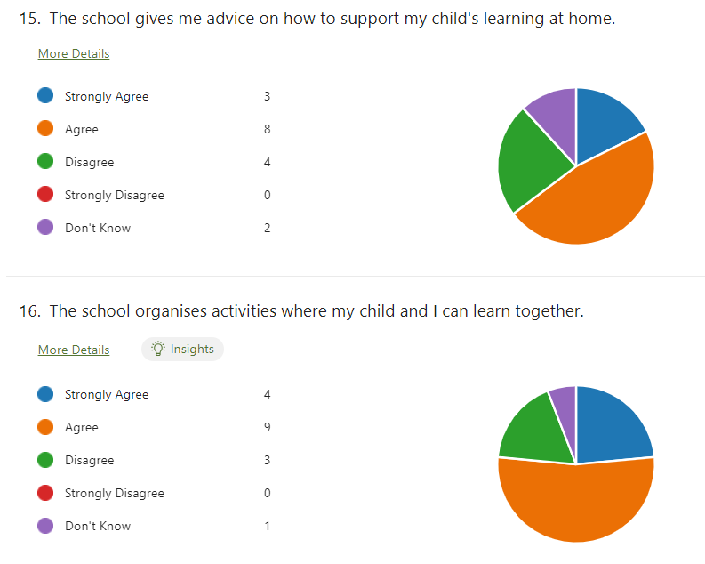  Parents also feel that they would like a greater understanding of how children are assessed to ensure the learning is hard enough.  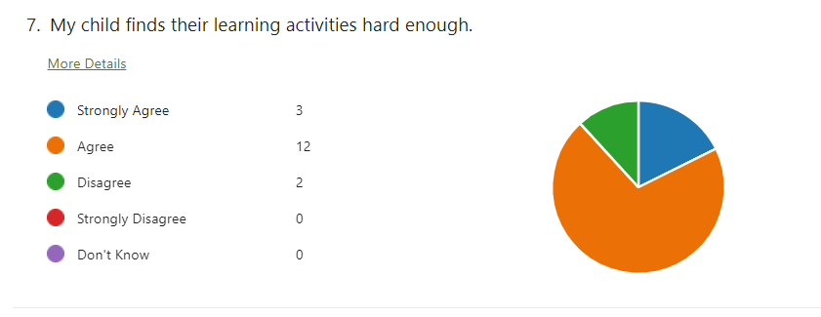  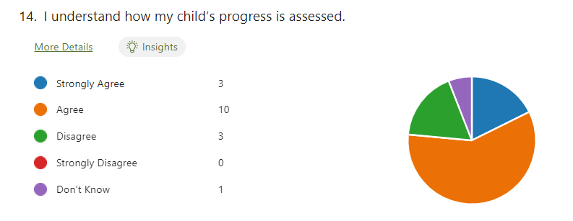  Pupils  Pupil surveys suggest that they feel positive about their work and feel they are doing well.  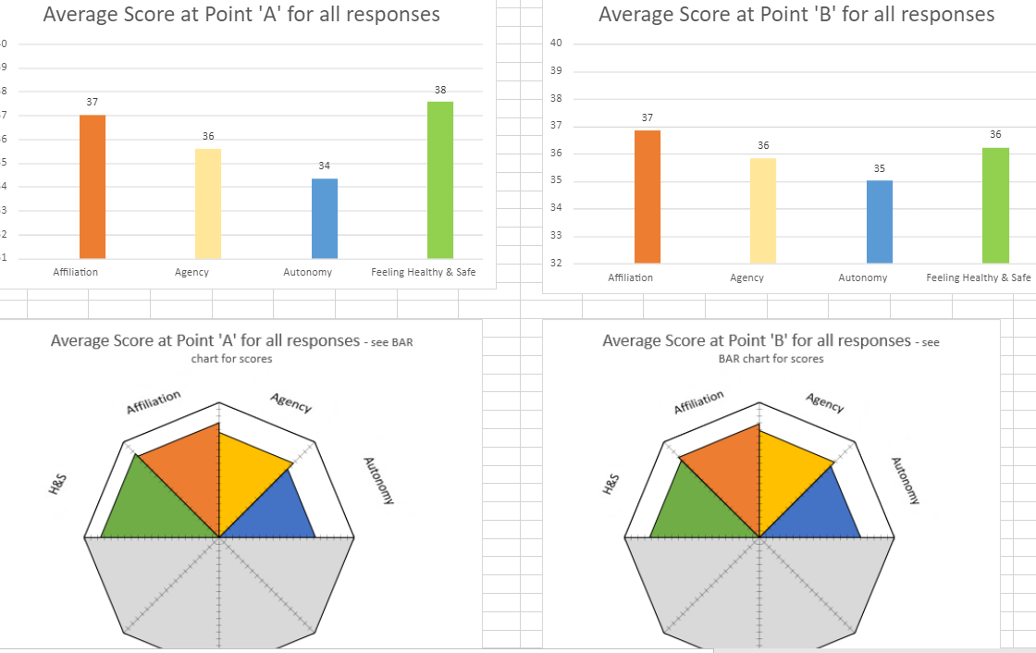  Pupil leadership conversations have suggested that children would like us to look at how they gain knowledge before taking on a task. They would also like us to explore homework.
Actions/Leadership | Impact |  | Measures
Actions  - Consultation with all stakeholders regarding homework – present research, present alternatives etc.  - Introduce self evaluation key questions for pupils to talk about their own learning alongside digital approach.  - Further develop play as a key component of our teaching and learning approach at Burnhaven. | Lessons are noticeable consistent across the school. Teachers are able to identify their strengths and what they would like to improve.  Learners are engaged in their learning and are able to explain how they are doing and what they need to do to improve.  Children are increasingly independent when writing and more children are achieving expected levels.  Homework is completed more consistently and this is leading to improved learning in school. |  | - Attainment data shows more consistent attainment across all stages and cohorts.  - Pupil questionnaires seem more authentic as children are more confident talking about their learning and their progress.  - Parent surveys show further confidence in children’s progress.  - Quality Assurance activities show increased focus on teaching and learning and evidence of development of key areas.
Professional Learning
- Direct input into what a good lesson looks like using inputs from Shirley Clarke and Mark Burns introduced last session and new Teaching and Learning provision from Local Authority Inservice Days.
- Engage in Talk for Writing Training when Available.
Policy Development
- Further develop our teaching and learning framework for professional learning.
- Homework policy/definition
Term 1 and 2 | Term 3 |  | Term 4
- Homework consultation and policy development.  - Collegiate meetings focused on areas agreed in our teaching and learning framework. Use Shirley Clark videos from CPD resource to encourage discussion and debate.  - Attend local authority inservice activities | - Talk for Writing inputs – when sessions become available.  - Attend local authority inservice activities.
Term 1 and 2 Evidence | Term 3 Evidence |  | Term 4 Evidence

Action plan 2
To improve learning, teaching and assessment through the creative use of digital technologies
Scottish National Improvement Priorities  - Placing the human rights and needs of every child and young person at the centre of education  - Improvement in children and young people's health and wellbeing  - Closing the attainment gap between the most and least disadvantaged children and young people  - Improvement in attainment, particularly in literacy and numeracy  - Improvement in employability skills and sustained, positive school-leaver destinations for all young people  Key drivers of improvement  School leadership  Teacher professionalism  Parental engagement  Assessment of children’s progress  School improvement  Performance Information |  | HGIOS and ELCC  1.1 Self-evaluation for self-improvement  1.2 Leadership for learning  1.3 Leadership of change  1.4 Leadership and management of staff/ practitioners  1.5 Management of resources to promote equity  2.1 Safeguarding and child protection  2.2 Curriculum  2.3 Learning teaching and assessment  2.4 Personalised support  2.5 Family learning  2.6 Transitions  2.7 Partnerships  3.1 Improving/ ensuring wellbeing, equality and inclusion  Specific to HGIOS 4  3.2 Raising attainment and achievement  3.3 Increasing creativity and employability  Specific to HGIOELC  3.2 Securing children’s progress  3.3 Developing creativity and skills for life |  | Aberdeenshire Priorities:  1. Improving learning, teaching and assessment.  2. Partnership working to raise attainment.  3. Developing leadership at all levels.  4 Improvement through self-evaluation.
Triangulated Evidence which Informs this Action:
Quantitative Data | Direct Observation |  | People’s Views
Attainment data cannot be shared due to percentages making children identifiable.  Data is available showing children’s improvement using targeted tools such as Nessy, Hairy Reader and Clicker. | Last session we worked on increasing digital literacy skills and computer science skills as well. Children have pushed themselves to create increasingly complex products and have engaged in this in their times of free choice.  Children have used technology to support their learning in targeted interventions.  We now want to pull these strands together in a strategic well so that teaching and learning is enhanced by the technologies already in use. |  | Parents  Parents have expressed an interest in children developing typing skills. Parent questionnaire suggests parents would like more information about what their children are learning and when. A digital approach may support this.  Staff  Scottish Government manifesto commitment to providing every child and young person in Scotland with a device means that schools need to be prepared for a 1-1 rollout across Aberdeenshire, considering how it will be implemented at a local level ensuring that best use of the devices are made to support learning and teaching in a meaningful way. GTCS requirement for all teachers to “demonstrate a depth of knowledge and understanding of the skills and competencies that comprise teacher digital literacy and know how to embed digital technologies to enhance learning and teaching.”
Actions/Leadership | Impact |  | Measures
Actions  - Revisit Features of Highly Effective Digital Learning, Teaching and Assessment in Schools (education.gov.scot) as a self-evaluation tool to assess where our school is at on our digital journey.  - Use challenge questions from 3.3 Creativity and Employability alongside GTCS standards for full registration to evaluate how well specific aspects with regards to digital technologies are fulfilled within the school.  - Audit devices and equipment currently in school. Assess most effective distribution of these devices to ensure pupils across the school have opportunities to develop their creative, digital skills across a range of software.  - Implement a digital profiling tool to share learning with parents and increased children’s evaluation of their own learning.  - Ensure digital approaches are embedded in teaching and learning.  - Review acceptable use policy at same time as school charters and class charters.  - Consider progress towards digital schools award. | All stakeholders have a clear idea of how digital pedagogy will be promoted and supported within the setting.  Policy will be agreed and understood by all stakeholders. Limited number of occasions where sanctions have had to be used.  Increase in digital skills across the whole of the school community.  Staff will be confident in accessing the support they require from their digital leader, peers, or LoveLearning team.  Positive attitude towards technology in the classroom and a willingness to have a go.  Pupils will be confident in using technology to support their learning. They will be able to talk about the extent to which they use digital technology to support their learning.  Increase in pupil engagement.  Pupils will be able to increasingly demonstrate choice in how they complete/present tasks in line with their own learning needs. Pupils will be able to demonstrate their creativity and use digital resources in innovative ways.  Pupils are able to get support with their device. Devices customised appropriately to individuals, will allow all pupils to access the curriculum in a manner which meets their needs effectively.  Administrative staff will be confident in troubleshooting simple Glow account issues so teaching and learning isn’t interrupted. |  | Self-evaluation activity will be carried out at key points throughout the year to assess progress.  Online safety is a key feature that will be evident across the school. Pupils will be able to articulate how to keep themselves safe online and will demonstrate responsible use of technologies.  SLT will gather evidence of digital pedagogy taking place in the classrooms via quality assurance processes including: observations, professional dialogue taking place at PRD/professional update meetings, monitoring of forward plans, sampling of pupil work.  Quality assurance processes will highlight areas of good practise to be shared across the school and areas where improvement is needed will be identified quickly and support put in place.  Tracking and monitoring processes identify an increase in engagement from pupils leading to an increase in attainment evident from analysis of data.  Teachers will report an increase in confidence in their own digital skills and how they can use technology to support learning and teaching in their class.  Pupils will be excited to share their work with peers, teachers and parents. An ethos of success and achievement will be evident within the school.  Feedback from support staff will show that they are confident in supporting pupils to use their devices.  Pupils will be able to talk about who they can go to in school to get support with their device. It will be evident from their use that devices are customised to meet individual needs appropriately and teachers will have confidence that pupils will be able to access their learning using features that enable that to happen. Pupils will be able to use and demonstrate those confidently.  Feedback from parents and pupils will be positive and demonstrate the benefits of using technology to support learning.
Professional Learning
- Teaching staff to participate in CLPL offered by the LoveLearning team to ensure that their professional abilities are in line with the level of digital literacy expected within the GTCS Standards for Full Registration. Use the Teacher Digital Literacy Framework (DRAFT) document or the self-reflection tool to critically and honestly evaluate where one’s own digital competence needs to be improved or updated, and to gather evidence for this requirement.
- Ensure attendance at LoveLearning November in-service for key members of staff taking the digital agenda forward and then disseminate to rest of school staff. Staff can also access information and training from Digilearn Scotland, Apple Teacher, MIE and Google.
- Watch videos for SMART Training for new smartboards
Policy Development
- Create a digital strategy for the school based on the professional learning and self evaluation actions we have engaged in, tying all the digital approaches that we have together.
Term 1 and 2 | Term 3 |  | Term 4
- Review acceptable use policy (Digital Schools Team)  - Audit resources and request news resources if appropriate from Parent Council. (Digital Schools Team)  - Staff to watch Smart videos and begin using new SMART boards  - Staff to audit personal training needs for PRD meetings.  - Attend LoveLearning in November as a team.  - Launch digital profiling. | With the help of the digital school team.  - Self Evaluation using features of effective digital practice and QI 3.3  - Creation of digital strategy  - Evaluate quality of digital profiling |  | - Evaluate progress this session and consider digital schools award led by the digital schools team
Term 1 and 2 Evidence | Term 3 Evidence |  | Term 4 Evidence

Action plan 3
Continue to create a supportive, nurturing environment for all our pupils which promotes their wellbeing.
Scottish National Improvement Priorities  - Placing the human rights and needs of every child and young person at the centre of education  - Improvement in children and young people's health and wellbeing  - Closing the attainment gap between the most and least disadvantaged children and young people  - Improvement in attainment, particularly in literacy and numeracy  - Improvement in employability skills and sustained, positive school-leaver destinations for all young people  Key drivers of improvement  School leadership  Teacher professionalism  Parental engagement  Assessment of children’s progress  School improvement  Performance Information |  | HGIOS and ELCC  1.1 Self-evaluation for self-improvement  1.2 Leadership for learning  1.3 Leadership of change  1.4 Leadership and management of staff/ practitioners  1.5 Management of resources to promote equity  2.1 Safeguarding and child protection  2.2 Curriculum  2.3 Learning teaching and assessment  2.4 Personalised support  2.5 Family learning  2.6 Transitions  2.7 Partnerships  3.1 Improving/ ensuring wellbeing, equality and inclusion  Specific to HGIOS 4  3.2 Raising attainment and achievement  3.3 Increasing creativity and employability  Specific to HGIOELC  3.2 Securing children’s progress  3.3 Developing creativity and skills for life |  | Aberdeenshire Priorities:  1. Improving learning, teaching and assessment.  2. Partnership working to raise attainment.  3. Developing leadership at all levels.  4 Improvement through self-evaluation.
Triangulated Evidence which Informs this Action:
Quantitative Data | Direct Observation |  | People’s Views
Pupil survey suggests that pupil autonomy needs further development.  Children have a positive view of the school and their learning but increased autonomy might lead to more authentic responses. | Children have developed their personalities a lot this year largely due to our widening of experience post pandemic. Working with local partners has given our children a wider range of environments for learning e.g Wyndwell Care Home and The Prison Museum. We need to continue to seek further partnerships. |  | Parents  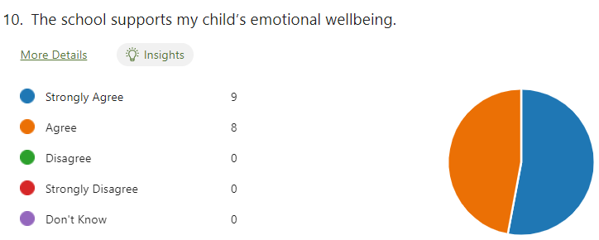  Parent questionnaires show positive views about how our children’s wellbeing is nurtured and how they feel safe. Parents noted that they were keen to support and understand children to resolve issues themselves. They also were keen that we have chickens in school to support children’s development of kindness.  Pupils  Children expressed that there is still a lot of unkindness and a lack of sportsmanship at playtimes. They feel that we should continue to work on our values. They would like us to further develop our outdoor space and asked why we still had not got chickens!  Staff  The resilience of our children and families is improving but we should continue this work.
Actions/Leadership | Impact |  | Measures
Actions  - Introduce the Circle Resource – audit, initial discussions  - Further explore outdoor learning  - Introduce chickens  - Introduce big deal, little deal  - Ensure Bounce Back is in place – including assemblies  - Revisit partnerships for the year ahead and seek new ones.  - Continue community groups and leadership discussions in assembly to further develop the work on awards. | Class teachers, learners and stakeholders are increasingly confident that our classrooms are as inclusive as possible.  Learners show increasing kindness to each other at playtimes and during games, resolving small issues themselves.  Partnerships continue to increase the variety of environments where young people are learning thus further increasing engagement.  Learners develop further empathy when caring for our chickens. |  | Ongoing consultations show that learners and families feel that their needs are being met within our inclusive classrooms.  Further reduced incidents of unkind behaviour/bullying behaviour in the playground.  Partnership evaluations demonstrate mutual benefits.  Possible Gold Rights Respecting School Award  Possible Eco Schools Award
Professional Learning
- HT to attend Circle Training in November
- Staff to look at Circle Resource and other resources during February inservice
Policy Development
- Further development of relationships policy
Term 1 and 2 | Term 3 |  | Term 4
- Set up chickens – hand over to Eco Group  - HT to attend Circle Training  - Create Assembly timetable to include bounchback messages, partnership invites, leadership questions. | - Audit classrooms using circle resource  - Evaluate progress towards rights respecting schools. |  | - Evaluate progress  - Issue annual stakeholder surveys
Term 1 and 2 Evidence | Term 3 Evidence |  | Term 4 Evidence

